AWS PROJECT
SECURE WEB APPLICATION DEPLOYMENT ON AWS EC2 USING CUSTOM VPC

- Objective: Deploy a production style web application on AWS EC2 using a custom VPC, security best practices and monitering, demonstating real world cloud and networking skills.
- Architechture:
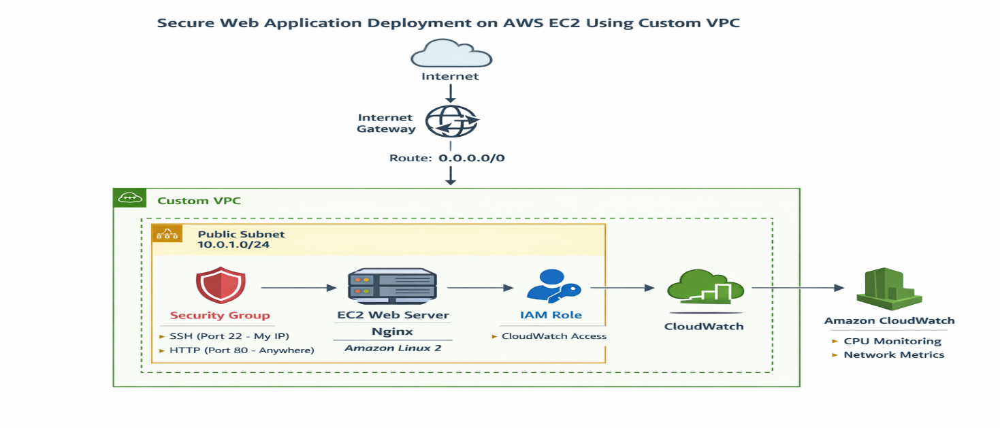
The architecture deploys a secure web applicationon AWS EC2 with customer VPC. The EC2 instance is hosted ina public subnet and connected to the internet using internet gateway, allowing the external users to access the web application. Security groups resticts inbound traffic to SSH and HTTP only, ensuring secure access.
An IAM role enables the EC2 instance to integrate the cloud watch or monitering systemsdemonstating a scalable, secure production oriented cloud deployment.
- The architechture consists of:
- Custom VPC
- Public Subnet
- Internet Gateway
- Route Table
- EC2 instance deployed in Amazon Linux
- Security Group
- IAM role
- Cloud Watch monitering.

- Technology Implemented:
The tools which used to deploy the project are:
- AWS EC2
- AWS VPC
- IAM
- Security Groups
- Cloud Watch
- Linux
- Nginx/Apache server

- Architechture Overview:
- VPC server: A custom VPC is created namely 10.0.0.0/16 to isolate the cloud resource and provid control over networking.
- Public Subnet: A public subnet is created namely 10.0.1.0/24 inside the VPC srver to host internet facing resources. It allows EC2 instance to access the internet and meanwhile suited for internet applications.
- Internet Gateway: It is attached to VPC to allow inbound and outbound internet traffic. It is stated as 0.0.0.0/0, enables public internet access for EC2 and it is used for HTTP/SSH connectivity.
- EC2 Instance: It is called Amazon EC2 Linux instance/web server which is used to host the web server using Nginx, servers HTTP traffoic and allows secure SSH access for administration.
- Security Group: Security group acts as virtual firewall. It consists of inbound rules like SSH 22 – my IP address and HTTP port 80. It is used to enforce least privilage security and prevents unauthorised access over the internet.
- IAM Role: It is attached to the EC2 instance with a permission enabled in cloud watch. It is secure to AWS services without access keys. It follws the rules enhanced by AWS security practices.
- Cloud Watch Monitering: Amazon cloud watch moniters CPU utilization, network traffic which is in and out signal. Its features includes enables performance monitering, helps high resource usage and demonstates operational awareness.
- Linux: It is an open source operating system based on Unix, widely used for servers, cloud platforms, network devics and security systems as it is stable, secure, Lightweight and highly configurable. Linux is important as it acts as a operational system that controls the server resources.
- It configures networking and security.
- Automate tasks using shell scripts.
- Install cloud and devops tools.
- Cloud workloads use linux as a main workload.

- Implementation:
- Step 1: The initial step is to create a VPC by enabling the necessary actions.
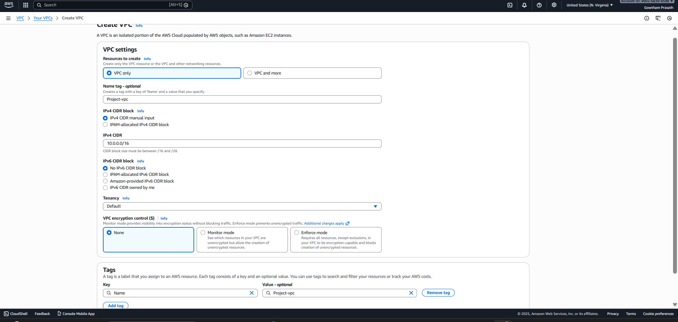
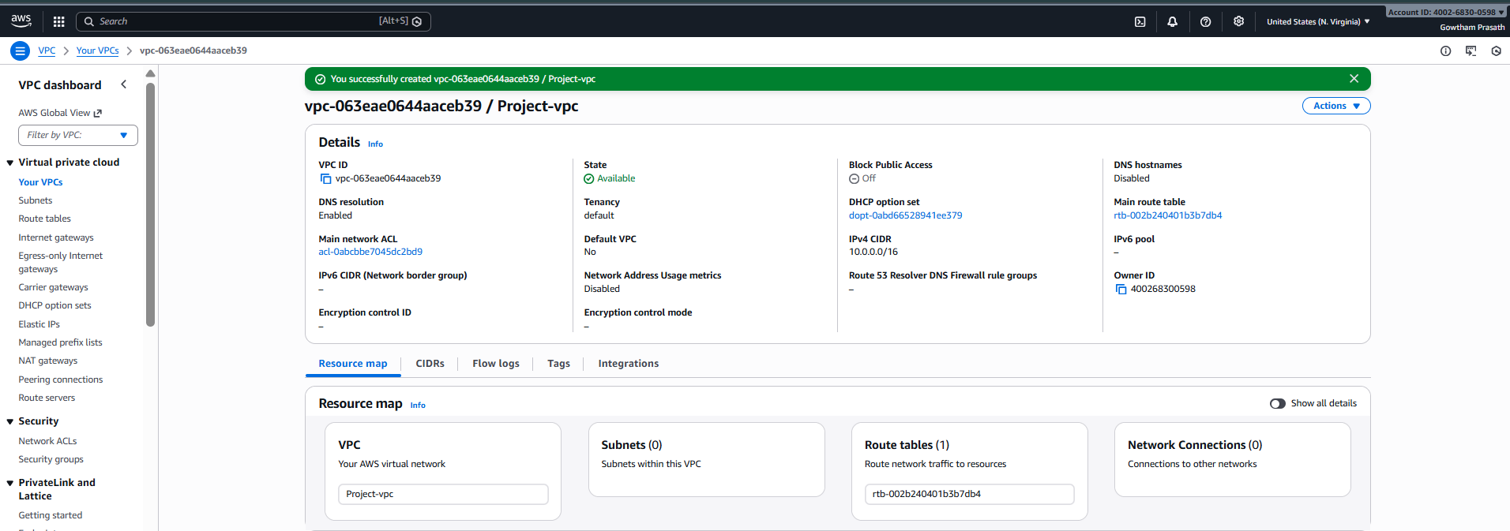
- Step 2: Create a Public Subnet in VPC dashboard.
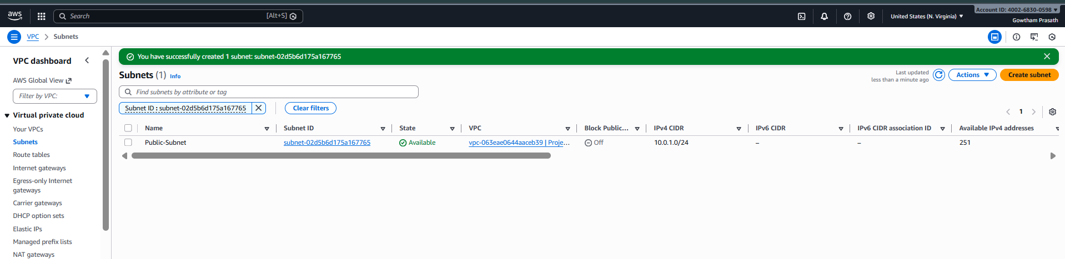

- Step 3: Enable auto-assign public IPv4 address in IP subnet settings.
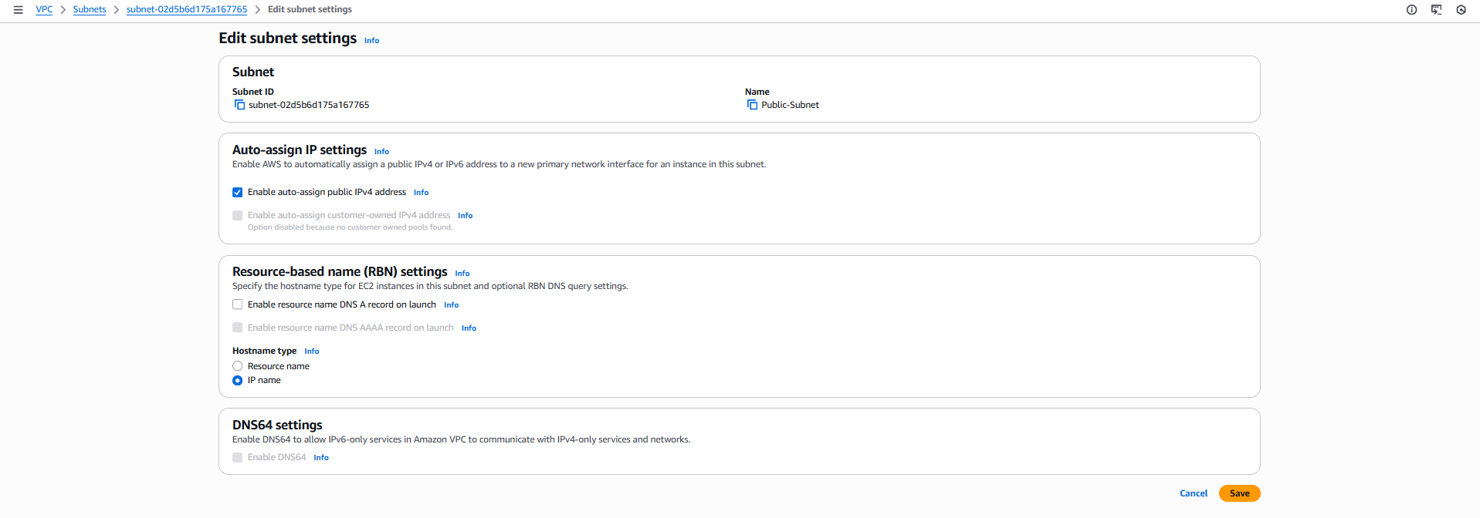
- Step 4: We can see successful change in public subnet settings and is auto-assigned.
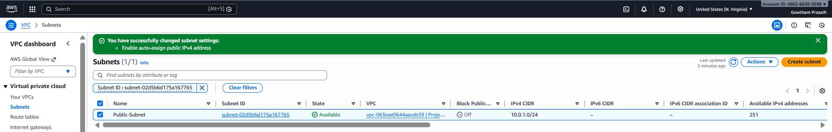

- Step 5: Go to VPC dashboard, create Internet Gateways and name it as ‘Project-IGW’. Go and create actions and attach to VPC and select Project VPC.
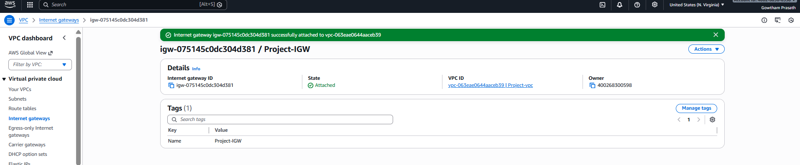

- We can see the two internet gateway are attached.
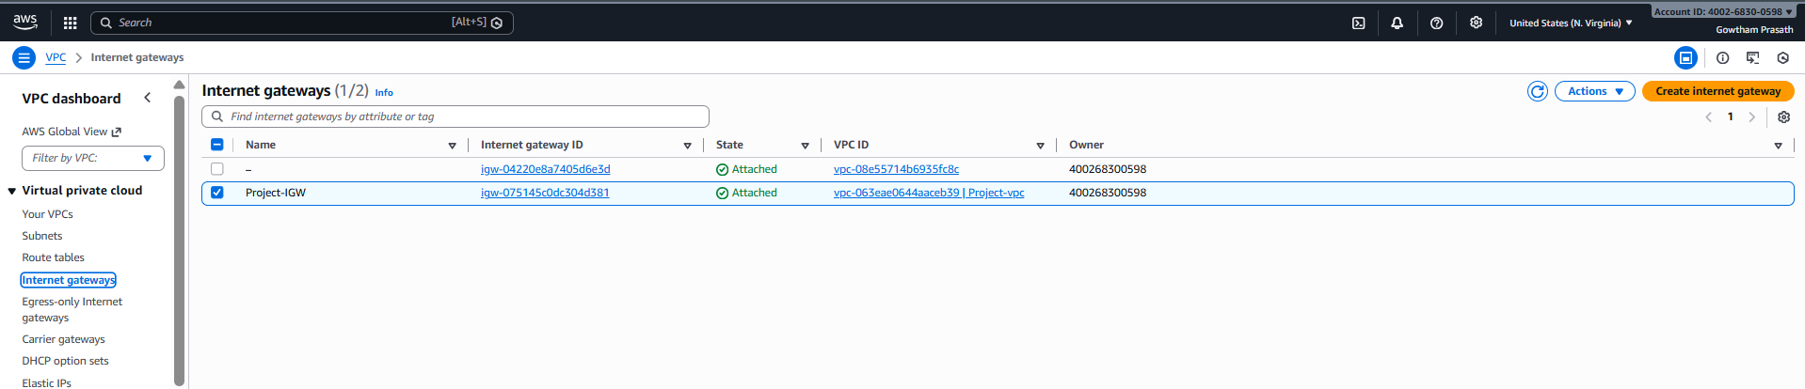

- Step 6: Go to Route Table, and select the route table associated with ‘Project VPC’ and edit route address and save.
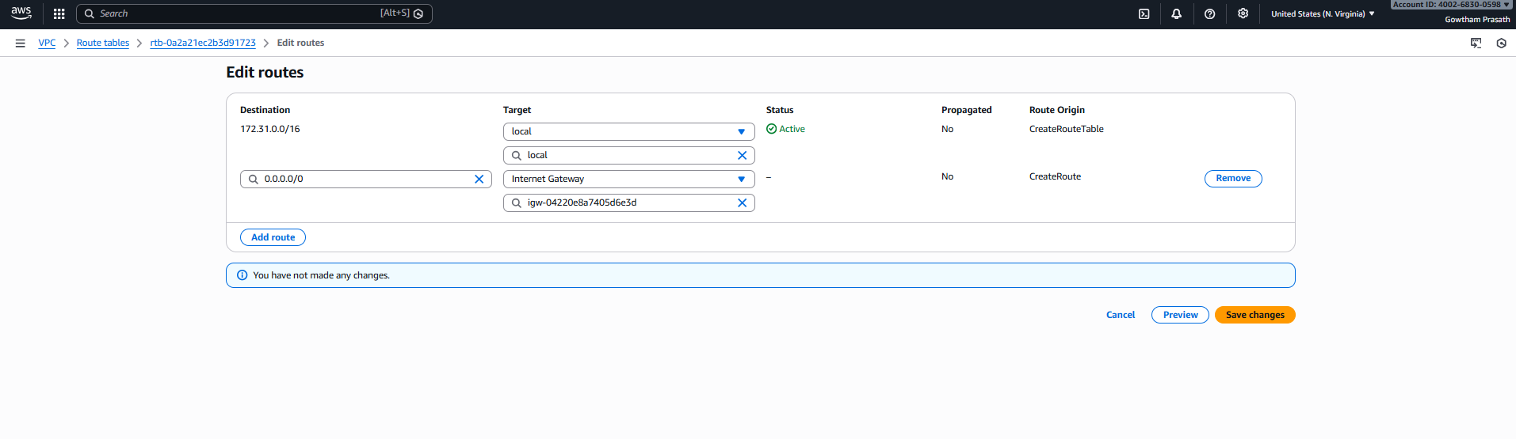
- You can now see the two route table addresses are created.
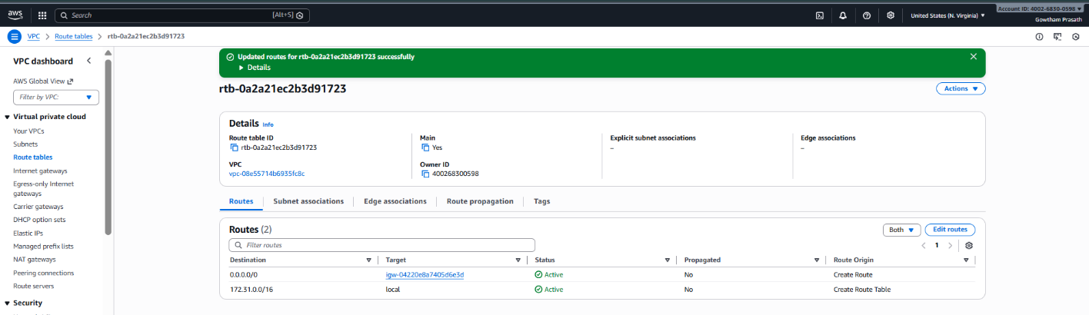

- Step 7: Go to EC2 and create security groups by naming web SG in project VPC. Name: Web-SG, allow HTTP and SSH in Project VPC, enable all the necessary statements of Inbound and Outbound rules and create security groups.
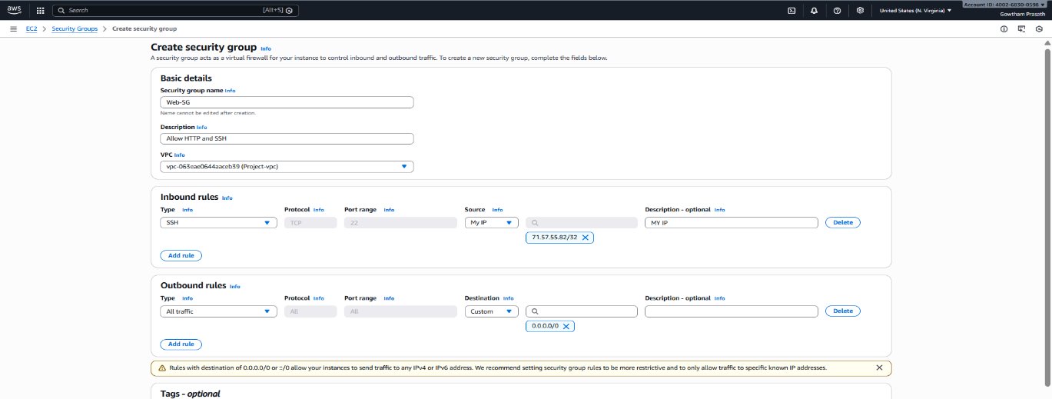

- Now You can see the Security Group Created for the project VPC.
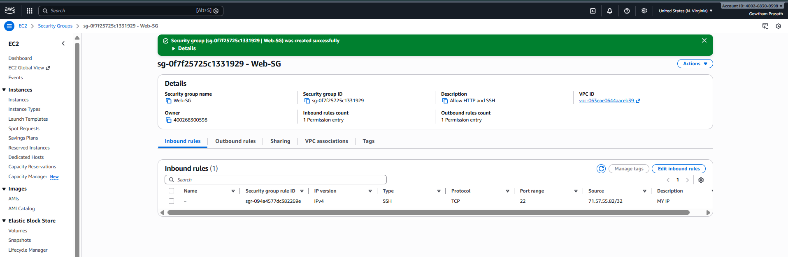

- Step 8: Now create an IAM role for EC2 instance. Go to IAM role and create IAM role, select AWS service as trusted entity and enable EC2 usecase.
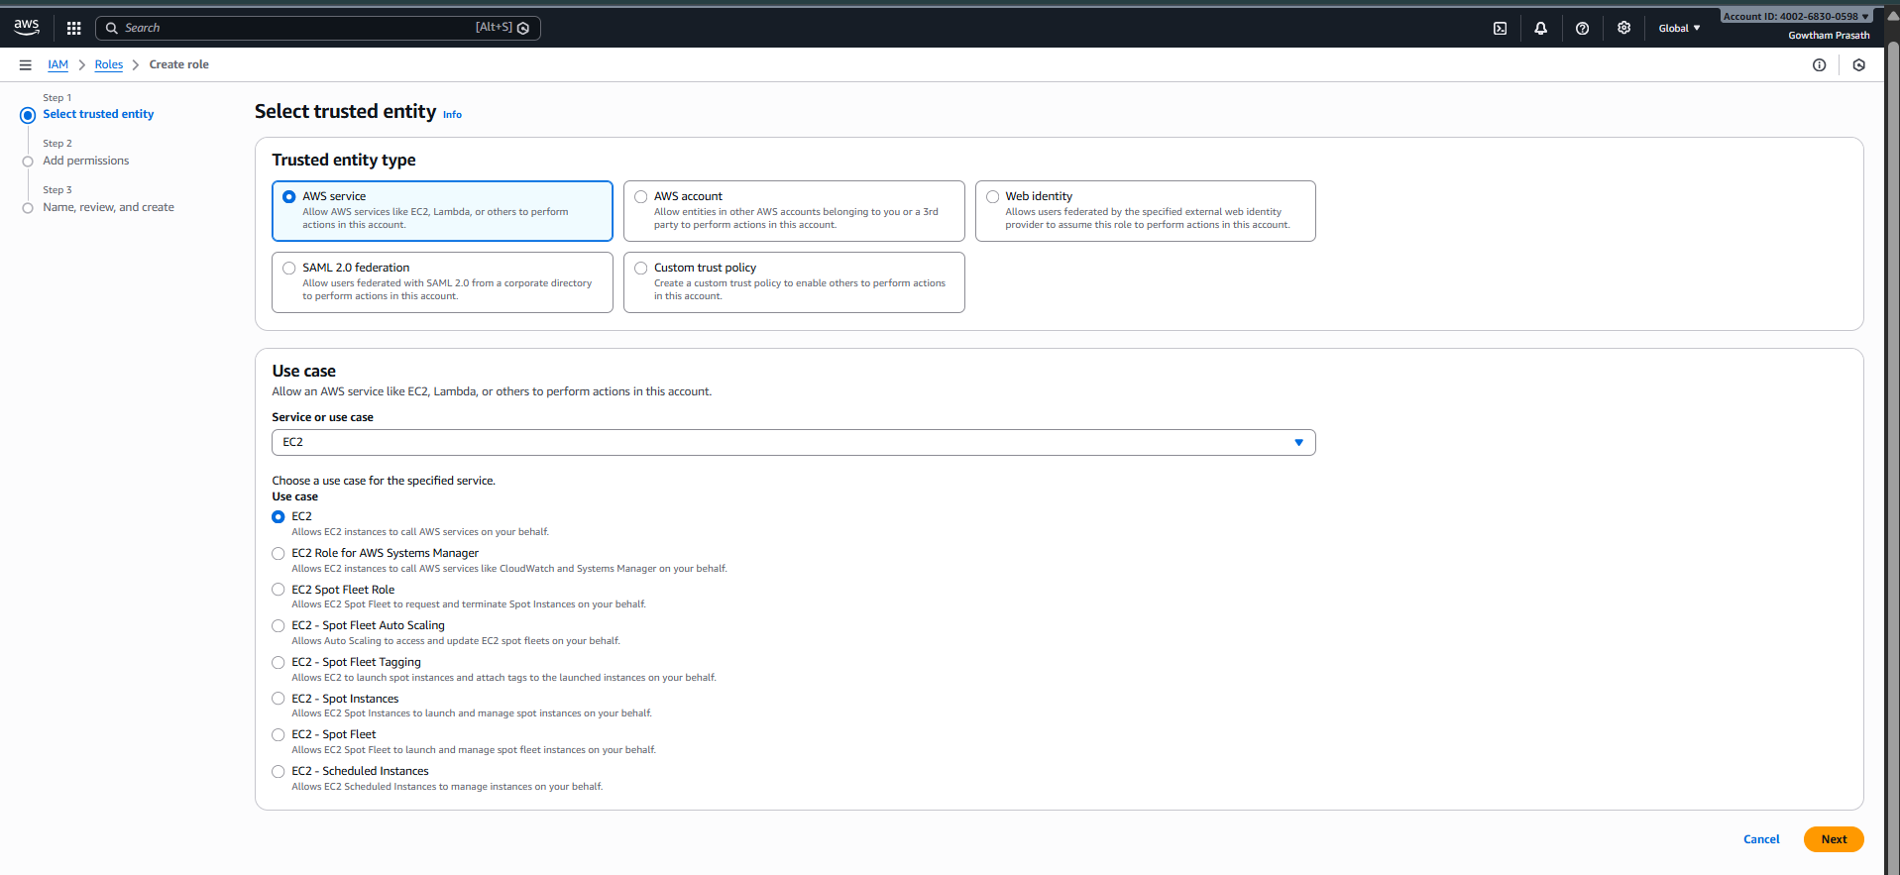
In role, create EC2 and then attach ‘CloudWatchReadOnlyAccess’ policy under the role name ‘EC2-CloudWatchRole’ and create role.
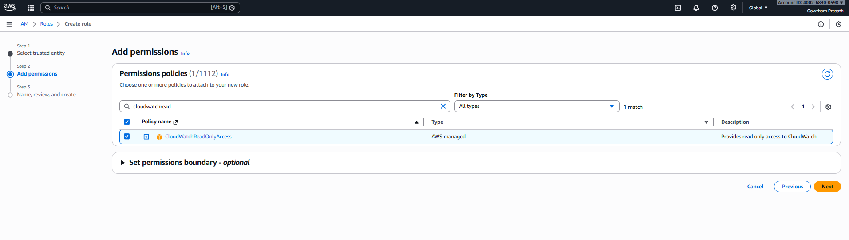
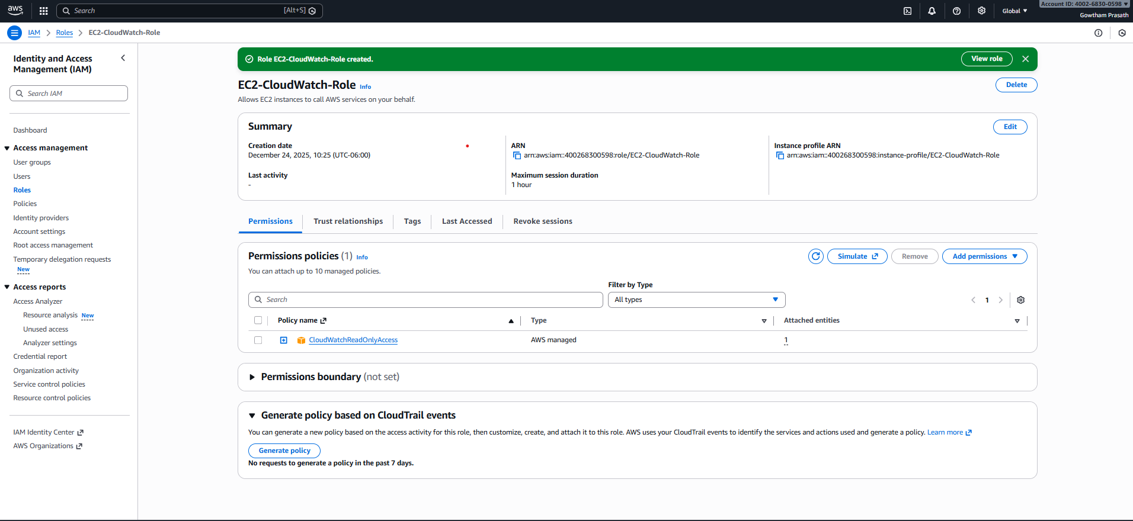
- Step 9: Go to EC2 and launch an instance naming ‘Web-Server-EC2’ , network settings as ‘Project-VPC’, in IAM role select ‘EC2-CloudWatch-Role’ .

- Now a Web-Server EC2 instance is created and running successfully.
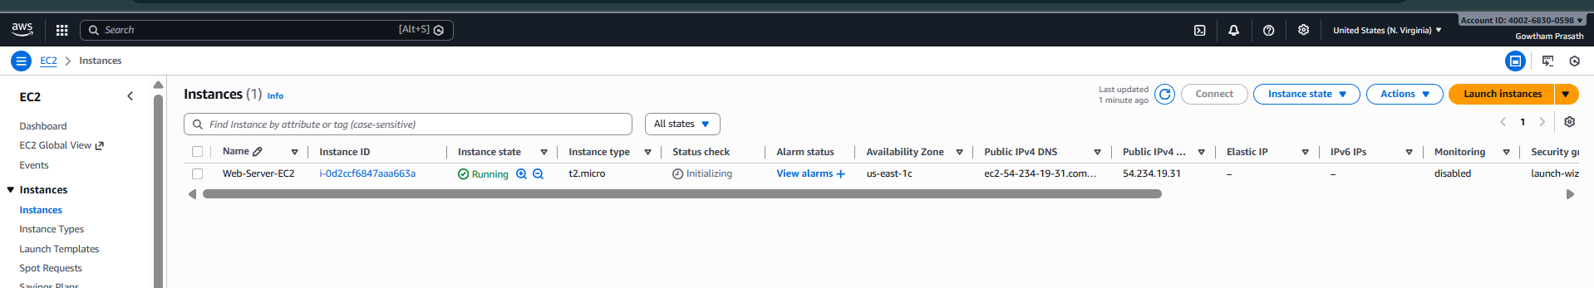

In OS, Select ‘Linux’ and name as Web-Server-EC2’ and the instance type set as ‘t2.micro’.
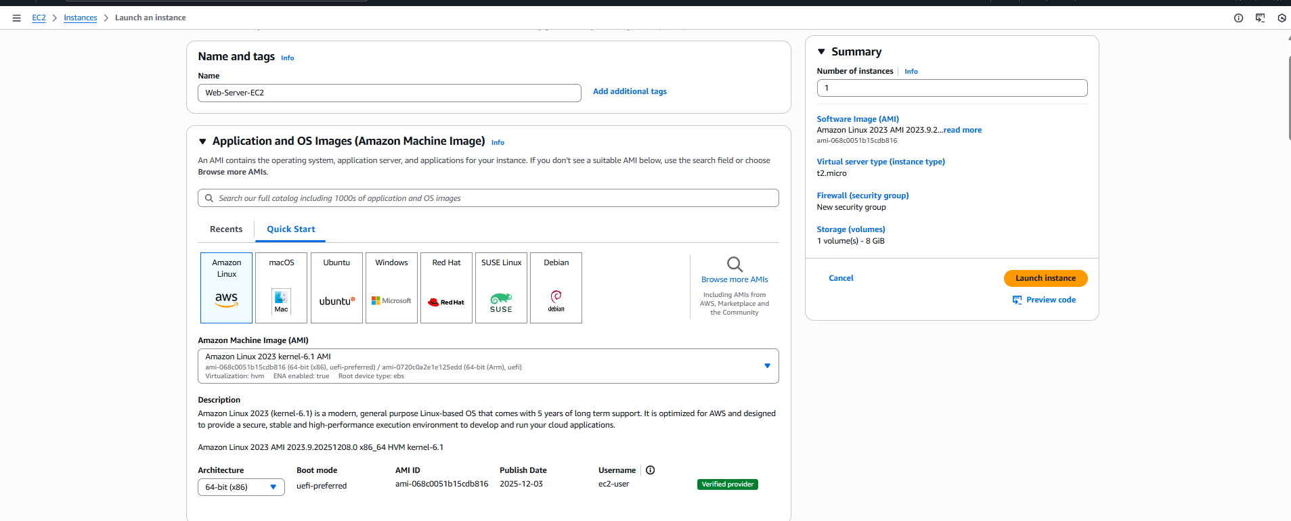

- Step 10: In network settings, add ‘Project-vpc’ and create a security group named ‘Web-SG’ with ssh key pair enabled.
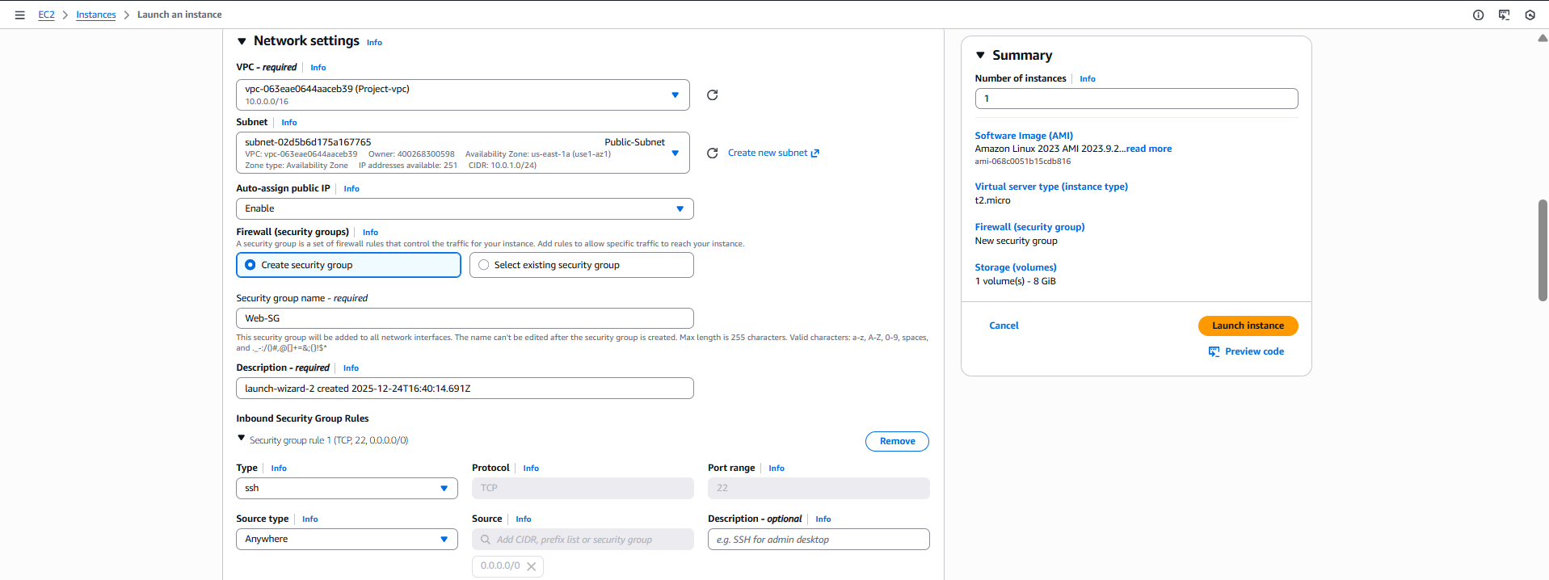
And in advanced settings enable ‘EC2-CloudWatch-Role’ and launch instance. There will be two instances named ‘Server-EC2’ and ‘WEBSERVER’ created and lauched succeessfully.
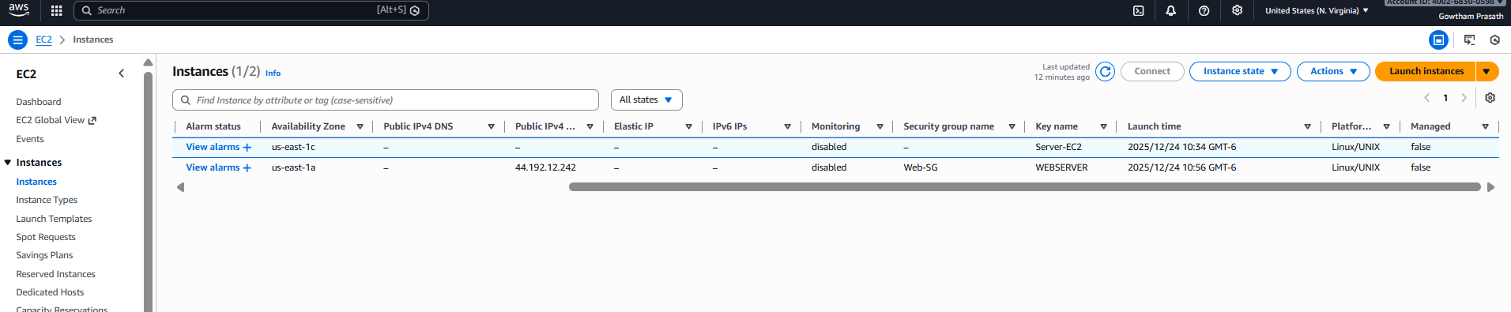

- Step 11: Now Select the EC2 and connect it using instance connect and run the following commands.
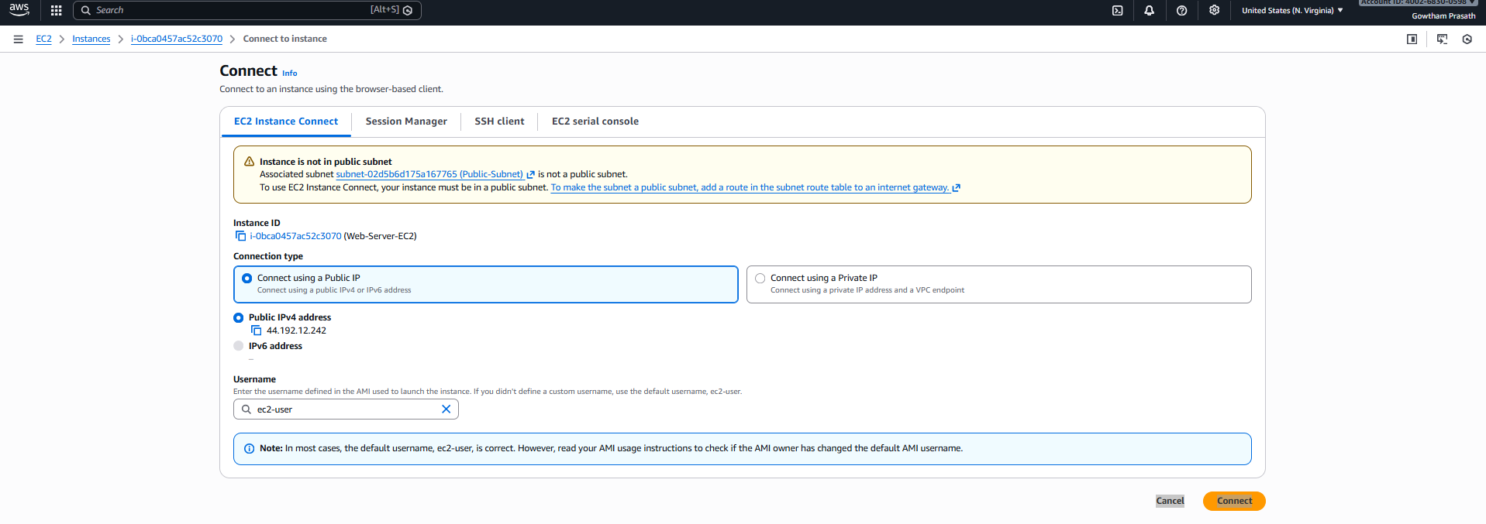

- Step 12: Now check in CloudWatch and ec2 instance in metrics and check if CPU utilization and network in/out bound is actively running .
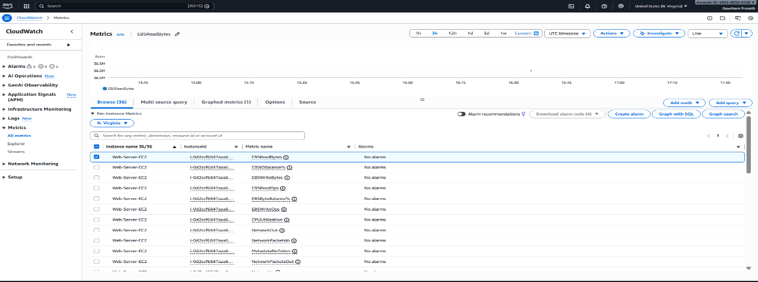
Cloud Watch Metrics is shown.

- The Output for the Secure Nginx server is displayed after the successful installation and connection of web application on ec2.

